Abbey Cottage 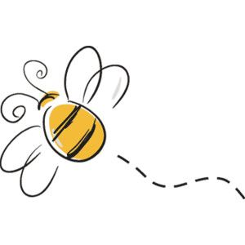
Sunday | Monday | Tuesday | Wednesday | Thursday | Friday | Saturday
 | 1  9:15 Aquatic Exercise  10:00 Balance Class AH  11:00 Mass PB  1:00 Music with Matt AH  *4:00 Wii Bowling League AH  Game Center | 2  10:00 Exercise Class AH  11:00 Communion Service PB  2:00 O’fallon Historical Preservation Speaker AH | 3  9:15 Aquatic Exercise  11:00 Mass PB  2:00 Bingo AH  Game Center | 4  10:00 Exercise Class AH  11:00 Communion Service PB  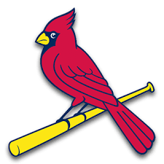  1-3:00pm Carinals Opener w/Moolicious Ice Cream Truck Tent  Game Center | 5  9:15 Aquatic Exercise  10:00 Balance Class AH  11:00 Mass PB  2:00 Happy Hour w/ Sterling MDR  *3:00-4:00 Stay and Chat MDR | 6  2:00  For Fun  AH  *6:00 Cards AH  Game Center
7  11:00 Mass  *Word wall pages AH  Game Center | 8  9:15 Aquatic Exercise  10:00 Balance Class AH  11:00 Mass PB  Eclipse Viewing on Porch  *4:00 Wii Bowling League AH  Game Center | 9  10:00 Exercise Class AH  11:00 Communion Service PB  2:00 Name that Dip Taste Testing AH  *4:00 Cards AH  Game Center | 10  9:15 Aquatic Exercise  11:00 Mass PB  2:00 Bingo AH  Game Center | 11  10:00 Exercise Class AH  11:00 Communion Service PB  1:00 Chapel with Chris Brown PB  2:00 Pictonary AH  Game Center | 12  9:15 Aquatic Exercise  10:00 Balance Class AH  11:00 Mass PB  2:00 Happy Hour w/ Ken Roberts MDR  *3:00-4:00 Stay and Chat MDR | 13  2:00  For Fun  AH  *6:00 Cards AH  Game Center
14  11:00 Mass  *Word wall pages AH  Game Center | 15  9:15 Aquatic Exercise  10:00 Balance Class AH  11:00 Mass PB  1:00 Music with Matt AH  *4:00 Wii Bowling League AH  Game Center | 16  10:00 Exercise Class AH  11:00 Communion Service PB  2:00 Apartment Meeting MDR  *4:00 Cards AH  Game Center | 17  9:15 Aquatic Exercise  11:00 Mass PB  2:00 Bingo AH  Game Center | 18  10:00 Exercise Class AH  11:00 Communion Service PB  3:00 Resident Council PB  Game Center | 19  9:15 Aquatic Exercise  10:00 Balance Class AH  11:00 Mass PB  2:00 Happy Hour w/ Anita MDR  *3:00-4:00 Stay and Chat MDR  Game Center | 20  2:00  For Fun  AH  *6:00 Cards AH  Game Center
21  11:00 Mass  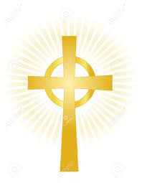  *Word wall pages AH  Game Center | 22  9:15 Aquatic Exercise  10:00 Balance Class AH  11:00 Mass PB  2:00 Pie on the Fly Baking MDR  *4:00 Wii Bowling League AH  Game Center | 23  10:00 Exercise Class AH  11:00 Communion Service PB  2:00 Sipping Club w/ Chris Brown MDR  *4:00 Cards AH  Game Center | 24  9:15 Aquatic Exercise  11:00 Mass PB  2:00 Bingo AH  Game Center | 25  10:00 Exercise Class AH  11:00 Communion Service PB  1:00 Chapel with Chris Brown PB  Game Center | 26  9:15 Aquatic Exercise  10:00 Balance Class AH  11:00 Mass PB  2:00 Happy Hour w/ John Scott MDR  *3:00-4:00 Stay and Chat MDR  Game Center | 27  2:00  For Fun  AH  *6:00 Cards AH  Game Center
28  11:00 Mass  *Word wall pages AH  Game Center | 29  9:15 Aquatic Exercise  10:00 Balance Class AH  11:00 Mass PB  2:00 Birthday Party MDR  Game Center | 30  10:00 Exercise Class AH  11:00 Communion Service PB  12:30-2:00 Reconciliation PB  2:00 Bingo AH  *4:00 Cards AH  Game Center

Activities are subject to Change.

