Sunday | Monday | Tuesday | Wednesday | Thursday | Friday | Saturday
A  P  R  I  l | 1  Wall Bingo  1-1  11:00 Mass PB  1:00 Music with Matt AH | 2  9:30 Rosary PB  10:00 Exercise Class AH  11:00 Communion Service PB  2:00 O’fallon Historical Preservation Speaker AH | 3  9:30 Rosary PB  11:00 Mass PB  2:00 Bingo AH | 4  10:00 Exercise Class AH  11:00 Communion Service PB  1-3:00 Home  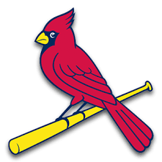  Opener w/Moolicious Ice Cream Truck Tent | 5  Wall Bingo  11:00 Mass PB  2:00 Happy Hour w/ Sterling MDR | 6  National Laughter Day w/ Leah
7  11:00 Mass  Weekend Activity Bins | 8  Wall Bingo  1-1  11:00 Mass PB  Eclipse Viewing on Porch | 9  9:30 Rosary PB  10:00 Exercise Class AH  11:00 Communion Service PB  2:00 Name that Dip Taste Testing AH | 10  9:30 Rosary PB  11:00 Mass PB  2:00 Bingo AH | 11  10:00 Exercise Class AH  11:00 Communion Service PB  1:00 Chapel with Chris Brown PB  1-1  2:00 Pictonary AH | 12  Wall Bingo  11:00 Mass PB  2:00 Happy Hour w/ Ken Roberts MDR | 13  National Licorice Day w/ Leah  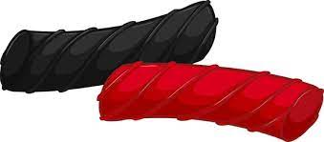
14  11:00 Mass | 15  Wall Bingo  1-1  11:00 Mass PB  1:00 Music with Matt AH | 16  9:30 Rosary PB  10:00 Exercise Class AH  11:00 Communion Service PB  2:00 Ice Cream Cart | 17  9:00 Love on a Leash  9:30 Rosary PB  11:00 Mass PB  2:00 Bingo AH | 18  10:00 Exercise Class AH  11:00 Communion Service PB  2:00 Resident Council PB  1-1 | 19  Wall Bingo  11:00 Mass PB  2:00 Happy Hour w/ Anita MDR | 20  National Banana Day w/ Leah
21  11:00 Mass  Weekend Activity Bins | 22  Wall Bingo  1-1  11:00 Mass PB  2:00 Pie on the Fly Baking MDR  Earth Day | 23  9:30 Rosary PB  10:00 Exercise Class AH  11:00 Communion Service PB  2:00 Sipping Club w/ Chris Brown MDR | 24  9:30 Rosary PB  11:00 Mass PB  2:00 Bingo AH | 25  10:00 Exercise Class AH  11:00 Communion Service PB  1:00 Chapel with Chris Brown PB  1-1 | 26  Wall Bingo  11:00 Mass PB  2:00 Happy Hour w/ John Scott MDR | 27  National Pretzel Day w/ Leah
28  11:00 Mass  Weekend Activity Bins | 29  Wall Bingo  1-1  11:00 Mass PB  2:00 Birthday Party MDR | 30  9:30 Rosary PB  10:00 Exercise Class AH  11:00 Mass  12:30-2:00 Reconciliation PB  2:00 Bingo AH

Abbey Senior Health
Activities are subject to change.

